SQL Server Data Type

A data type is an attribute that specifies the type of data an object can hold , as well as how many byte that type of data takes up.

* Character string data type
* Unicode character string data type
* Numerical data type
* Temporal(date/time) data type
* Other(Large character and binary values, xml, geometric data, geographical data, hierarchical data)

**Character String Data type**

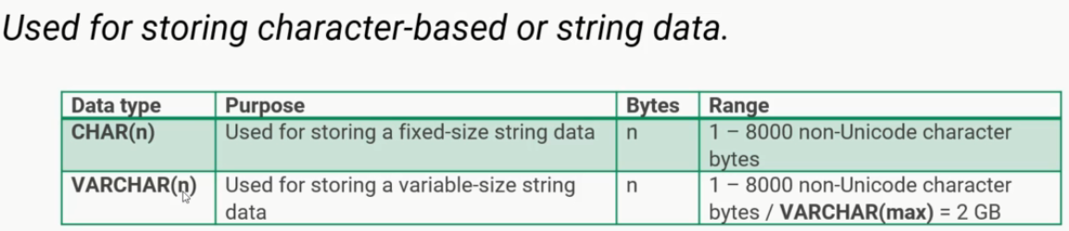

Char(n) will allocate fixed full size as n , so even if variable is small it will take full size as in n.

Varchar(n) size will depend on size of actual variable.

N : indicates the maximum size of the data

i.e : size does not mean the length of the data , depends on encoding / os.

1char = 1 byte or 1char =2byte

**Unicode character string data type**

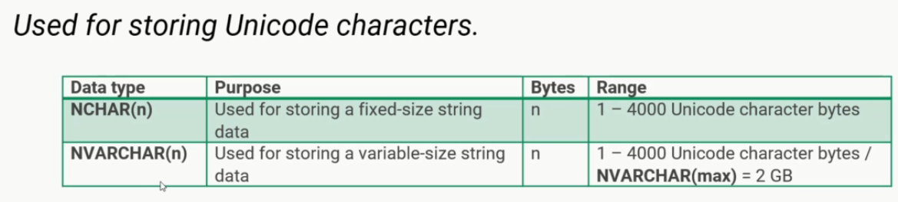

Range is 1 – 4000 not like varchar (1-8000) as uncode character requires more space in storage

This is best suited for application using localizations or special characters .

**Temporal (Date/Time) data type**

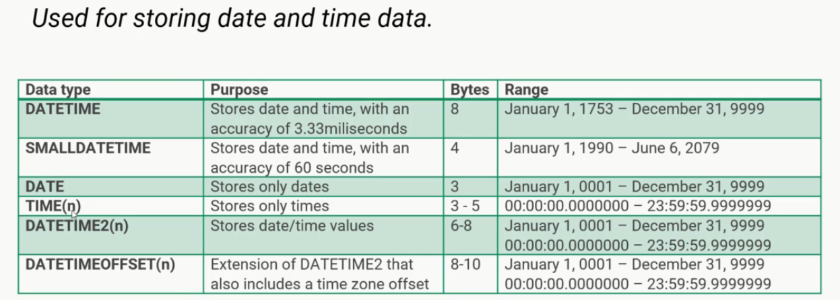

**Numerical data type**



